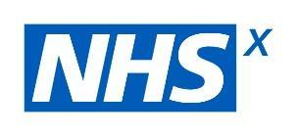
AI in Health and Care Survey 2021
Comms Pack
11 January 2021

2021 Project Overview
NHSX, in collaboration with the AHSN Network, is inviting contributions to a survey which aims to provide a snapshot of AI development and implementation in health and care, including the impact of the NHS AI Lab.
This exercise follows on from the surveys that were held in 2018, to understand what AI-driven technologies were being developed, and in 2019, to understand where they are being developed, what problems they are solving and collect more tangible information on the data and regulatory landscape.
Findings from 2019 were highlighted in Artificial Intelligence: How to get it right report and helped lead to the conclusion that creating the NHS Artificial Intelligence Lab would be essential to help accelerate the safe, ethical and effective adoption of AI in health and care.
This year, we seek feedback on the work conducted to-date by the NHS AI Lab and to engage with developers and procurers of AI-driven technologies to gain their perspective on the maturity of the landscape and progress to-date, alongside new opportunities and risks identified.
We hope that through these actions we can make the UK the best place to safely and ethically develop, deploy and use AI-driven technology for health and care technology.
Background
An initial baseline survey was conducted in 2018 by the national AHSN Network AI Initiative. The survey was created by a core advisory group of 40 leaders and innovators survey.
Over 130 organisations and projects contributed to this survey that enabled an map of AI activity in the UK to be created and also informed the development of the report, Accelerating Artificial Intelligence in health and care: results from a state of the nation survey’.

The additional publications of the Code of Conduct (now the Guide to Good Practice) and Topol Review helps to address the need for agile regulation for AI and workforce education and engagement.
The 2019 survey looked to understand where AI-driven technologies are being developed, what problems they are solving and collect more tangible information on the data and regulatory landscape.
The subsequent report, Artificial Intelligence: How to get it right, was an overview of the current state of play of AI-driven technologies within the health and care system, covering everything from the local research environment to international frameworks in development.
Informed by research conducted by NHSX and other partners over the past year, it outlined where in the system AI-driven technologies can be utilised and the policy work that is, and will need to be done, to ensure this utilisation is done in a safe, effective and ethically acceptable manner.
Purpose of comms pack
This pack is to support the release of the 2021 survey, expected to run for five weeks from 13 January.
We appreciate that you may currently be focusing all of your comms activities on COVID-19, however any help you can give to promoting this survey would be greatly appreciated.
Included in this toolkit
- Tweets
- Linkedin posts
- Newsletter copy

Social Media
Hashtags
 | #AIecosystem #AIsurvey #NHSX #AHSNNetwork #NHSAILab
Image
Simple tweet 1 | Image
Give us your thoughts on #AI-driven technologies for health and care in our 2021 AI survey. https://www.surveymonkey.co.uk/r/L2W2BGQ #AIecosystem #AIsurvey #NHSX #AHSNNetwork #NHSAILab | 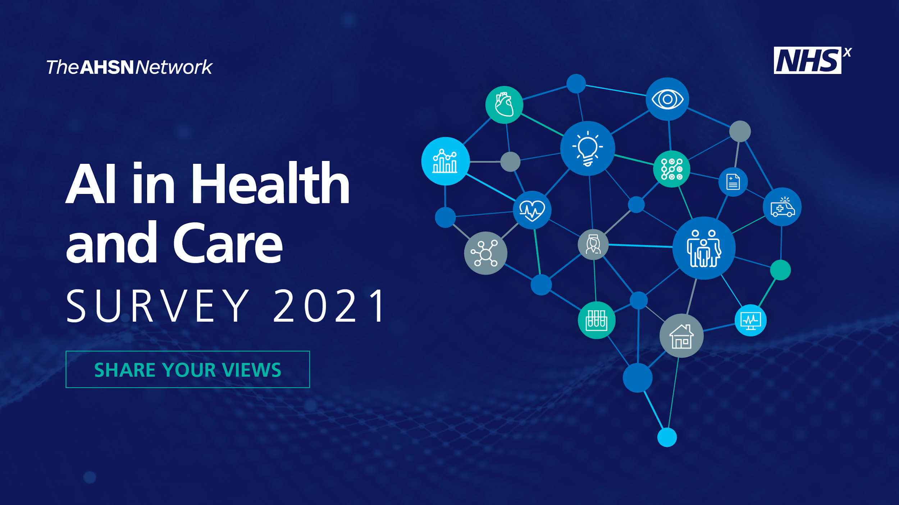
Simple tweet 2 | Image
Want to have your say on the adoption of AI-driven technologies in health and care? Complete the new 2021 survey. https://www.surveymonkey.co.uk/r/L2W2BGQ #AIecosystem #AIsurvey #NHSX #AHSNNetwork #NHSAILab
Longer tweet | Image
Our annual AI survey is live. Help the NHS AI Lab and AHSN Network understand the supply of AI-driven technologies to improve health and care in 2021
https://www.surveymonkey.co.uk/r/L2W2BGQ
Your input will shape the future of harnessing data in UK health & social care
#AIecosystem #AIsurvey #NHSX #NHSAILab

Linkedin
Post 1:
Want to have your say on the adoption of AI-driven technologies in health and care? The 2021 AI in Health and Care Survey is now live and asking for input from digital health innovators, developers and those procuring and implementing AI for health and care.
The survey, from the NHS AI Lab (NHSX) with the support of the AHSN Network, will identify key developments within AI space, understand the settings that AI-driven technologies are being developed for, as well as the importance of education, medical classification, ethics and wider system support for the deployment of these technologies.
Dr Indra Joshi, Director of AI for NHSX, says the findings will influence the work of the NHS AI Lab: “The NHS AI Lab is committed to accelerating the safe, ethical and effective adoption of AI in health and social care. This survey enables commissioners and innovators to inform the Lab’s work so the UK continues to be a leading place to develop and test AI-driven technologies at scale for use in health and care.”
Complete the survey: https://www.surveymonkey.co.uk/r/L2W2BGQ
#AIecosystem #AIsurvey #NHSX #AHSNNetwork #NHSAILab

Post 2:
Are you a digital health innovator, developer or involved in procuring or implementing AI-driven technologies for health and care? The 2021 AI in Health and Care Survey is your chance to have your say on the adoption of AI in health and care, and inform the work of the NHS AI Lab.
The survey, from the NHS AI Lab (NHSX) with the support of the AHSN Network, will identify key developments within AI space, understand the settings that AI-driven technologies are being developed for, as well as the importance of education, medical classification, ethics and wider system support for the deployment of these technologies.
By taking part you’ll be able to inform the NHS AI Lab’s work, helping the UK continue to be a leading place to develop and test AI-driven technologies at scale for use in health and care.
Complete the survey: https://www.surveymonkey.co.uk/r/L2W2BGQ
#AIecosystem #AIsurvey #NHSX #AHSNNetwork #NHSAILab

Post 3:
There’s still time to make your voice heard in the 2021 AI in Health and Care survey.
The NHS AI Lab (NHSX) will use the findings to inform its future work in accelerating the safe, ethical and effective adoption of AI-driven technologies in health and social care.
The survey builds on findings from similar surveys in 2018 and 2019, both of which resulted in new resources and guidance being created for the AI community, including the AI: How to get it right report, the creation of a Code of Conduct (now the Guide to Good Practice for Digital and Data-driven health and care technologies), and the Buyer’s Guide to AI in Health and Care
Complete the survey: https://www.surveymonkey.co.uk/r/L2W2BGQ
#AIecosystem #AIsurvey #NHSX #AHSNNetwork #NHSAILab

Post 4:
Want to have your say on the adoption of AI in health and care? The 2021 AI Health and Care Survey is now live and asking for input from digital health innovators, developers and those procuring and implementing AI-driven technologies for health and care.
Dr Indra Joshi, Director of AI for NHSX, says the findings will influence the work of the NHS AI Lab: “The NHS AI Lab is committed to accelerating the safe, ethical and effective adoption of AI in health and social care. This survey enables commissioners and innovators to inform the Lab’s work so the UK continues to be a leading place to develop and test AI-driven technologies at scale for use in health and care.”
The survey builds on findings from similar surveys in 2018 and 2019, both of which resulted in new resources and guidance being created for the AI community
Complete the survey: https://www.surveymonkey.co.uk/r/L2W2BGQ
#AIecosystem #AIsurvey #NHSX #AHSNNetwork #NHSAILab

Newsletter copy:
The AI in Health and Care Survey 2021
Want to have your say on the adoption of AI in health and care? The 2021 AI in Health and Care Survey is now live and asking for input from digital health innovators, developers and those procuring and implementing AI-driven technologies for health and care.
The survey (https://www.surveymonkey.co.uk/r/L2W2BGQ), from the NHS AI Lab (NHSX) with the support of the AHSN Network, will identify key developments within AI space, understand the settings that AI-driven technologies are being developed for, as well as the importance of education, medical classification, ethics and wider system support for the deployment of these technologies.
Dr Indra Joshi, Director of AI for NHSX, says the findings will influence the work of the NHS AI Lab: “The NHS AI Lab is committed to accelerating the safe, ethical and effective adoption of AI in health and social care. This survey enables commissioners and innovators to inform the Lab’s work so the UK continues to be a leading place to develop and test AI-driven technologies at scale for use in health and care.”
Complete the survey (https://www.surveymonkey.co.uk/r/L2W2BGQ) now
ENDS

Suggested email content to send to relevant networks or contacts:

Email subject: Have your say on the adoption of AI in health and care

Dear ,
We’ve been contacted by the NHS AI Lab (NHSX) about its 2021 AI in Health and Care survey, and thought this could be particularly relevant to your work.
By taking part in the short survey (https://www.surveymonkey.co.uk/r/L2W2BGQ) you will be able to have your say on the adoption of AI-driven technology in health and care and influence the future work of the NHS AI Lab.
Previous survey resulted in new resources and guidance being created for the AI community, including the AI: How to get it right report, the creation of a Code of Conduct (now the Guide to Good Practice for Digital and Data-driven health and care technologies), and the Buyer’s Guide to AI in Health and Care
The survey, which is supported by the AHSN Network, aims to identify key developments within the AI space, understand the settings that AI-driven technologies are being developed for, as well as the importance of education, medical classification, ethics and wider system support for the deployment of these technologies.
It should only take 5-10 minutes to complete the survey, which you can access here
(https://www.surveymonkey.co.uk/r/L2W2BGQ).
Thanks,

NAME

ENDS

