Consultations Summary –
Department for Digital, Culture, Media & Sport
New Consultation: UK National Data Strategy (NDS) consultation
• Closing: 02/12/2020

This consultation is based on the National Data Strategy which was launched during Tech Week 2020 and calls for advice on whether the aforementioned strategy considers all potential opportunities of the hyper-tech world of today and any potential trade-offs and decisions to be made. This UK-wide consultation is aimed at tech-rich companies, data-driven organisations, law firms and governance bodies among others.
Questions are asked on the below flow chart in terms of how well the priorities of the strategy are set out.
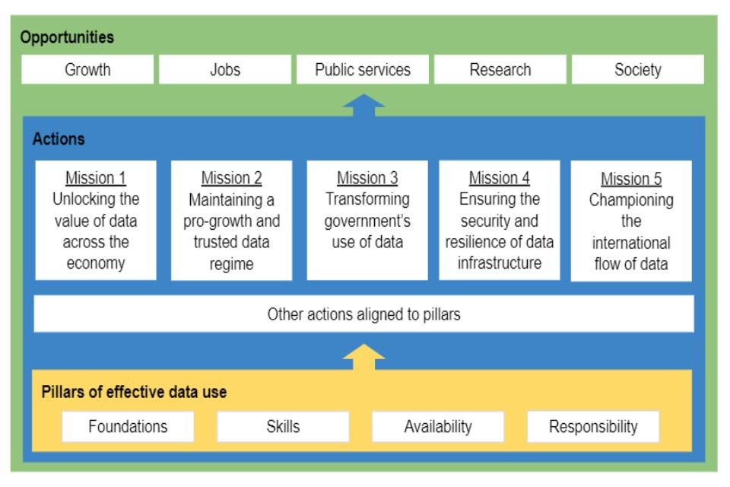
The strategy aims to create an environment where data is appropriately usable, accessible and available across the economy. The role of central Government in enabling the availability of data is also queried. AI monitoring and the usability of the Data Protection Act is the second mission described in the text. Mission three is based around views on any actions companies think will have the biggest impact for transforming government’s use of data. Mission four addresses data security and protocols, as well as the level of involvement Government should play in this factor. The last mission is around cross-border flows of data information internationally. Questions are asked about any barriers to cross-border data movement and improvements of current data transfer mechanisms,
This is a 12-week consultation period with a response due by Government in early 2021.
More info here.
Intellectual Property Office
New Consultation: Artificial intelligence and intellectual property: call for views
Closing: 30/11/2020

This consultation seeks view on the effects of Artificial Intelligence (AI) on Intellectual Property (IP). The IP Office is looking to build on the Government’s Research and Development Roadmap that it has previously set out.
It also needs to know the impact of IP on AI. There are five sections to the consultation: patents, copyright and related rights, designs, trade-marks, and trade secrets.
Questions surrounding patents involve the usability of AI for inventing, the claim of inventorship if AI is used and should patent law allow AI to be identified as the sole or joint inventor?
Questions around copyright involve questions such as should the copyright framework make it easier for AI to use protected content? Other questions involve the need for clarity around when AI infringes copyright, protection for copyright and database owners when AI is used, if AI itself is eligible for copyrighting.
The design section addresses AI being termed an author or owner of a UK or Community design, and who should be recognised as the author of a design created by AI where the system has been bought from a supplier, and the buyer has provided input or data to the system? Does evidence need to be provided in cases where AI no longer becomes used by a human?
The trade-mark section asks if there are difficulties in current trade-mark law that needs adapting due to AI. Questions are asked such as does AI affect the concept of the “average consumer” in measuring likelihood of confusion? Can the actions of an AI infringe a trade-mark?
The last section on trade secrets, it asks if trade secret protection is important for AI? The advantages of using trade secrets in the AI sector and the potential problems of trade secrets for the ethical oversight of AI inventions.
More info here.

