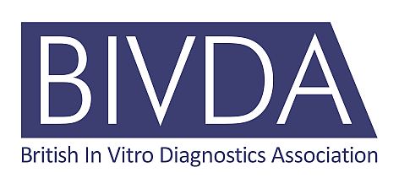

NOMINATION FORM
FOR MEMBERSHIP OF EXECUTIVE BOARD, TERM 2025/2028

NOMINEE Name:

Company:

Position:

I confirm that this nomination is made with the knowledge, support and agreement of my employer and that my current position within the company is a senior leadership level and carries appropriate decision-making authority for the company and for representing the interests of the IVD sector.

Signed:

Date:

Please provide name and contact details for BIVDA to contact for a reference to support your nomination.

Name:
Position:
Telephone:
Email:

Please return this form, by Wednesday 26 February at 17.00.

Please provide a supporting statement and digital photograph by email to helen.dent@bivda.org.uk

The supporting statement should be about 300-500 words briefly giving the candidate’s experience and why they would like to represent the membership on the BIVDA Executive Board.

